**Design And Development of Activated Carbon-Based Solar Air Purifier**

*1Reshma P Eldho*

1Assistant Professor, Department of Electrical and Electronics Engineering, CMR Institute of Technology, Bengaluru, India

*2Durga Rani, 3Anand Prakash Tiwari, 4Mohammed Ashraf, 5Akanksha*

2,3,4,5 Student, Department of Electrical and Electronics Engineering, CMR Institute of Technology, Bengaluru, India

**Abstract:** Air pollution has skyrocketed in the past few years which has increased the respiratory and trigger diverse neurological disorders for kids as well as adults. Such health issues has triggered so many new illness and deficiencies in the human body which has to be taken care appropriately. Damage to neural cells brought on by fine dust, particularly in fetus and newborns, can result in persistent brain damage or adult neurological diseases. The fastest temporary solution is to provide a clean and healthy atmosphere in both the public and private spaces. The proposed system is developed to provide a renewable and reliable solution for the air purifiers by implementing it with a solar based energy source in a low cost and a much greener way.

**Keywords**: Sensors, air purifier, solar panel, Renewable energy, pollution, microcontroller

1. **INTRODUCTION:**

Due to increased traffic air pollution has become a serious problem these modern days, introduction of new microbes and viruses and even the exhaust gases that is released from factories, manufacturing industries, etc. This Pollution is not just present outside in environment, its indoor as well in places like hospitals, schools, colleges, our homes and so on. Moreover, clean and purified air is an essential part to having a proper healthy lifestyle, especially to the people who suffer from neurological problems or respiratory illness like Asthma, wheezing and so on. According to the survey conducted by WHO, Solid fuels (wood, dung, crop wastes, charcoal, coal, etc.) and simple stoves is been used for cooking and heating by 2.8 billion people, and simple kerosene lamps is used to light homes by 1.2 billion people. Very high level of household air pollution is been created by these kind of household practises. There is an increase in broad range of health problems due to hazardous substances emitted from construction materials, buildings and equipment from factories and this results in air quality of people spending their life in gets polluted, places like offices, hospitals, schools, homes, religious buildings, etc. [1]

|  |  |  |
| --- | --- | --- |
| **POLLUTANT NAME** | **SOURCES** | **DISEASES** |
| Sulphur dioxide (SO2) | Fires, Coal burning power, petroleum refineries, metal smelting, etc | SO2 can cause respiratory problems such as bronchitis, and can irritate noise, throat and lungs. |
| Ozone(O3) | Pollution emitted from cars, power plant, industrial boilers, etc | Chest pain, coughing, throat irritation and congestion. |
| Particulate matter (PM) | Sea salt, dust (such as airborne soil) and pollen | Lung’s cancer, reduced lung function and heart disease. |
| Nitrogen Dioxide (NO2) | Vehicles, industrial emissions, road sources, power plant etc. | Lung’s disease, asthma, chronic obstructive pulmonary disease |
| Carbon Monoxide(CO) | Vehicles, bushfires | Smog, heart damage, chest pain |

Table 1: Various atmospheric Pollutants and their after-effects on humans

Smoke from cooking/tobacco, household products and pesticides release harmful gases such as carbon monoxide and radon, pollen, asbestos used in paints/buildings, and formaldehyde are indoor pollution’s main sources. These impurities generally size between 2.5 to 10 microns. Ambient average air quality being monitored in the cities like Delhi, Ghaziabad and so on has grown so worse in the past few year which increased the necessity of purifiers. Average concentration of pollutants is generally termed in µg/m3[2]. The environment has the highest pollutant concentration of PM10, PM2.5, SO2, NO2, CO as shown in table 1 which is very difficult to remove from the atmosphere. To prevent all these dangerous impurities and gases, a reliable purification system is a requisite tool. Hence, the development of solar-powered air purifier is an attempt towards improving air quality using a renewable source of energy. Although many air purifiers are available in market these days, implementation of purifier using renewable is still a nascent market. The project develops a standalone solar based sir purification system for indoor application. The proposed prototype aims to filter allergens, atmospheric particulates, pollutants and irritants from the atmosphere and enhance sir quality. It undergoes a double filtration process to capture medium and small particles. The filters include:

* a HEPA filter for catching particles such as pet dander and pollen.
* an activated carbon filter that captures odors and other gases.
  1. **LITERATURE SURVEY:**

There are various air purification methods which are experimented and adopted by researchers. Major filters include HEPA filters, UV light filters, Electrostatic filters, activated carbon filters and so on. **HEPA** High-efficiency granular air filter is a machine-like filter which acts as a mesh for the incoming particles. It can filter very fines particles like mould, dust, some bacteria till 0.3 microns depending upon the quality of the filter and the age of the filter. Pollutants and allergens are tapped and sieved mechanically in **Activated Carbon filter** similar to that of a HEPA filter. The substantial use in the filter is the main difference between these two air purifiers. As polluted air passes through energized carbon which is a specially treated material that consists of high spongelike feature, it will soak up the pollutants as air is passing through the filter. To clean the air in surrounding, any filter is not been used by an ionizer air purifier. To make charged ions opaque that are emitted from air purifiers they are fused with air borne particles. The heavier or denser particles fall onto the ground or surface after moving freely in the air. The disadvantage of these kind of air purifiers is that, until you don’t clean the adulterant from the filter it still exists inside the room. Hovering germs like pathogen and bacilli are destroyed by short-wave UV-C light feature that is installed in **UV** **light** air purifiers. Ultraviolet Germicidal Irradiation (UVGI) is a cleanse method which is used in this type of air purifiers. In this method air is directly disinfected as it passes near the UV lamp when air is passed through the air purifier. [3].

|  |  |  |
| --- | --- | --- |
| Title | Topology & Objective | Advantages |
| Designing and Simulating a Smart Air Purifier to Combat HVAC-induced COVID-19 Transmission  **The New Jersey Governor’s School of Engineering & Technology, Rutgers University–New Brunswick, NJ, USA.** | The module’s structure is outlined using Computer Aided Design, its Internet of Things networking capabilities are mapped out using microcontrollers and a mobile application, and its potential impacts are modeled using computational fluid dynamics (CFD) simulations. | The proposed module uses proven technology to capture and deactivate SARS-CoV-2 with high fidelity. Although a set of modules cannot replace an HVAC system in terms of satisfying ACH requirements, it can work in conjunction with HVAC by treating infected air before it is blown across the room by HVAC currents. |
| Portable Air Purifier with Air Quality Monitoring Sensor  **Proc. XXVIII International Scientific Conference Electronics - ET2019, September 12 - 14, 2019, Sozopol, Bulgaria** | Air quality has become a major concern for citizens all over the world. It is well documented that Fine Particulate Matter (FPM) is a health hazard which can affect the cardiovascular system, respiratory system, etc. and lead to high mortality rates. This study presents the development and implementation of an innovative portable air purifier. The device can be used to improve air quality in small spaces. | The PM particle collection efficiency of the PAP was examined for particles with a diameter in the range 0.3 – 5 us in a test room under different operating modes. The experiments confirm the good effectiveness of the proposed solution. It can be extended to humidity control as well as to control over wireless sensor networks. |

* 1. **COMPONENTS & ITS SPECIFICATIONS:**

1. Solar Panel: A 20 watt,12V foldable type polycrystalline solar panel is used for the application as shown in figure 1 (a). The advantage of this kind of panel is that it is portable and compact making it easy to handle. It is used for charging two batteries alternatively.

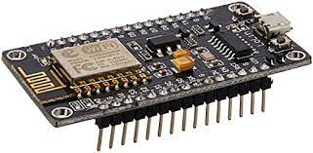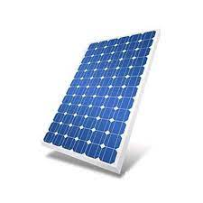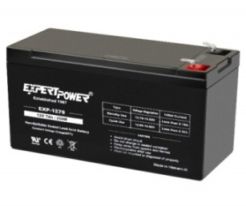

Fig 1: a) Solar Panel b) 7 Ah Battery c) NODE MCU

1. Battery: Two numbers of 12V, 7AH Lead Acid rechargeable battery is used for the development of the prototype. The Solar panels are consistently generating energy when exposed to sunlight. The energy is stored in a electrochemical battery as shown in 1 (b) which is discharged to power the actuators, microcontrollers and sensors.
2. NODE MCU:The NodeMCU in figure 1 (c) (Node MicroController Unit) is a free and open source software and hardware expansion environment that is built around a very economical System-on-a-Chip (SoC) called the ESP8266. It has 17 GPIO (General input output) pins which can be designated to various justifications like I2C, Sensors, LCD. NODE MCU has a memory of 128KB and storage of 4MB. Operating Voltage: 5V DC.
3. Suction Fans: This will pull the polluted air from the environment to within the model. Each fan covers an area of 5 SQ ft. Operating Voltage: 12V DC.
4. Carbon Filter and HEPA Filter: These filter out harmful organic chemicals present in air, like Dust, allergens, Floor Dust, pollens, harmful Smoke and carbon monoxide gas, bad odour, soot particles, etc as shown in. HEPA (High efficiency particulate air) filters consist of fibres which are arranged in a disorganized manner in a matrix. These fibres mostly consist of [polypropylene](https://en.wikipedia.org/wiki/Polypropylene) or fibre that are 0.5-2.0 micrometres in diameter. Much more than 0.3 um is the gap space between the fibres of HEPA filter. Very high level of smaller particulate matter is filtered put by HEPA filters. To filter out gasses the most commonly used filter is carbon air filter. There is an activated layer of carbon which is specifically designed to filter out gasses.
5. Sensors: Basically, there are 3 sensors which are used. (i) dust sensor, (ii) carbon filter © HEPA filter as shown in figure 3. All the 3 sensors require an operating voltage of 5V DC. Dust sensor senses dust particles in air, Cigarette smoke with a sensitivity of 0.5V/ (0.1mg/ m3). MQ3 Sensor detects Alcohol (Perfumes, Sanitizers) concentration from anywhere around 25-500 PPM. MQ4 Sensor detects Smoke, Methane, Natural Gas, Combustible gasses from the atmosphere.

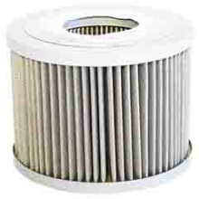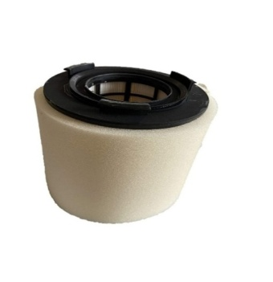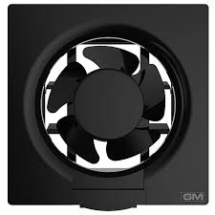

Figure 2(a)Suction Fans (b)Carbon Filter (c) HEPA filter

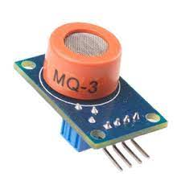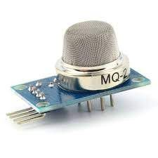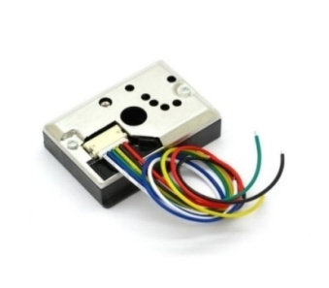

Fig 3: Sensors a) Dust Sensor b) MQ3 sensor c) MQ4 Sensor

1. 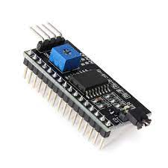I2C module and Voltage Regulator (7805): It has an inherent PCF8574 I2C chip that transforms serial data to parallel data for the LCD display. It acts as a mediator between Node MCU and LCD display. Voltage Regulator (7805) regulates the voltage level as per the requirements of different components. Operating Voltage: 5V DC.

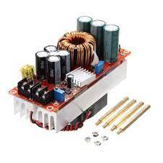

Fig 4: I2C Module and voltage regulator

1. Relay and LCD Display: Figure 5 shows relays and LCD display which is used in the proposed system. It acts as a switching device, if any sensor gets triggered Node MCU will send the signal to relay to provide the supply for suction fans. It also prevents flowing of reverse of 12V from battery to Node MCU, where only 5V is required. It basically has 3 pins (NO, NC, COM). It will display if there is any pollution in the air and the impurity levels in it. This is a 16x2 alphanumeric display. Operating Voltage: 5V DC

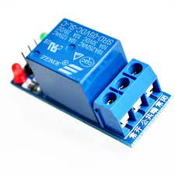

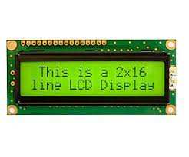

Fig 5: Relay and LCD Display

* 1. PROPOSED SYSTEM

The proposed system utilizes multiple filtration methods to make the incoming polluted air more purified and improve the output air quality. The implementation diagram of the proposed system as shown in figure 6 consist of air monitoring systems powered by solar panels. The focus is on extracting the pollutant air and passing it through the filtration system and getting cleaner air as output. The strainer works to take in fumes, gases, enzymatic, and aura that are existence in the air and are equipped that can produce cleaner and fresher-smelling air. The main parameter from which air quality of a certain environment is determined, is by knowing the concentration of gasses and various solid pollutants present in the air. Knowing what’s the good daily air quality index for a healthy lifestyle is essential for people, especially for those people who suffer from diseases related to air like asthma, wheezing, etc. Hence an effective but economical development of an air purifier is essential.

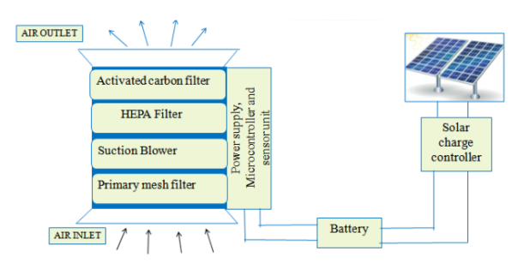

Figure 6: Implementation diagram for solar based air purifier

The block illustration of the proposed structure is shown in figure 7. Moreover, table 2 shows various components used for the implementation of the prototype. The model consists of Solar panel (for energy supply), battery technology (for storing power generated from the solar panel for later use), air filters and air quality monitoring system. An Air Pollution Monitoring System senses various impurities in the atmosphere which will monitor the Air Quality over an LCD display, when the sensor senses various harmful gases that are present in the air like combustible gasses, dust, smoke, alcohol. LCD will display the air quality in mg/m3, from this monitoring of air quality is simplified.[4]-[5]. Whenever impurity is detected, the sensors allow power on and allow automatic suction of the impure air. To detect pollutants from air we are using few Air quality Sensors like MQ3(Alcohol, LPG), MQ4(Combustible Gas, Methane), Dust Sensor (PM 2.5). Our solar air purifier consists of 3 suction fans that sucks air from three sides of the purifier and the air is taken inside the model and pushed through carbon filter and HEPA filter for purification, from this bad odour, gasses like smoke, dust, alcohol are filtered out and cleaner air is pushed through the filters because of the centrifugal air force inside the model.

Filtered air is liberated at the outlet. The purifier design is based on the dimension of the enclosed premise. The dimensions of the room are the initial step in the design. Clean air delivery rate (CADR) points out to how much air has to pass through the filter in every second. The entire system is powered using solar energy source which is stored in the battery.

As soon as these sensors detect impurities in air, they send a signal that suction fan has to be turned on. This will be displayed in LCD as “Pollution Detected” and DC Suction Fan will be turned on and polluted air will be taken inside the filter box and passed through purifiers (Carbon filter & HEPA filter) and cleaner air will be received as output. The supply will be taken from 20 watts Solar Panel, which will power all the components, a second battery is present as backup. When the supply is given all the components will be turned on. Through hotspot we will connect to IOT. LCD will display the project title “SOLAR AIR PURIFIER”, and the air condition as “NORMAL”.

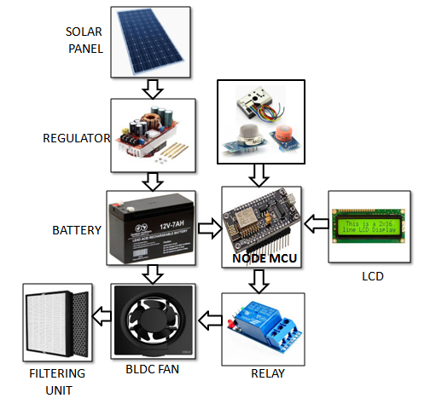

Figure 7: Block diagram of the proposed system

|  |  |  |
| --- | --- | --- |
| **Sl. No** | **Component Name** | **Component specification** |
| 1 | Solar Panel | 20 watt/12V foldable Solar Panel |
| 2 | Battery System (2 units) | 7AH |
| 3 | Microcontroller Unit | 5V DC, 32 Pins |
| 4 | DC Brushless Fan (3 no’s) | 12V |
| 5 | HEPA Filter |  |
| 6 | Activated carbon filter |  |
| 7 | Air quality sensor (MENTION 3 SENSORS) |  |
| SENSOR. 1 MQ 4 | | 5V (Combustible gas, Methane) |
| SENSOR. 2 MQ 3 | | 5V (Alcohol, LPG, CO) |
| SENSOR.3 PM 2.5 | | 0.5V/ (0.1mg / m3) |
| 8 | Charge Controller | 5V (Voltage regulator) |
| 9 | LCD Display | 5V,16*2 |
| 10 | Relays | 5V,3Pin (NO, NC, COM) |

Table 2: Component list and budget details of the prototype

Dust sensor employed will check for impurities at three levels:

1. Minimum Impurities: 0.35mg/m3

2. Medium Impurities: 0.5mg/m3

3. Maximum Impurities: 0.75mg/m3

If any one of the sensors gets triggered, controller will send the signal to relay and the suction fans will be turned on. Polluted air within the specified area will be taken inside the model and passed through air filters and it will be purified.

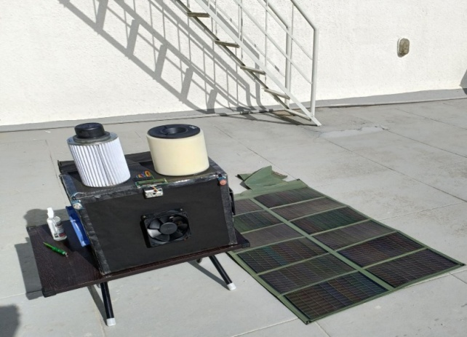 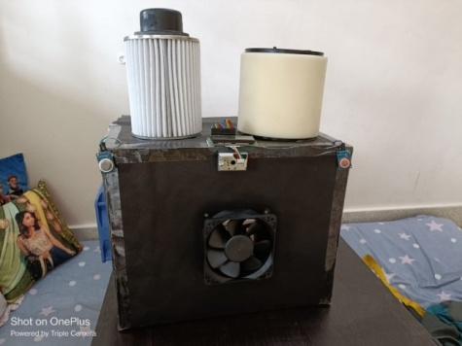

**Fig 8: Prototype of Solar Air Purifier**

* 1. **MICROCONTROLLER PROGRAMMING**

The flow chart shows in Fig.9 shows the working algorithm of the code used in our model. In the model we have used 3 sensors. At first all the required initialization of variables is done with the pin values provided in NodeMCU processor for storing the values, and proper Pin mode for all is set. With the analogue output received from the particular sensor Dust density value is calculated. Using a simple if-else condition loop the pollution level is checked for different levels and is classified as Maximum, Minimum and Medium impurities. Since we have used 2 MQ series sensors also, it gives the digital value accordingly when the impurities are detected and are checked using if condition. Whenever the impurities are detected by the sensors, the alert messages showing the impurity level are displayed over the LCD display.

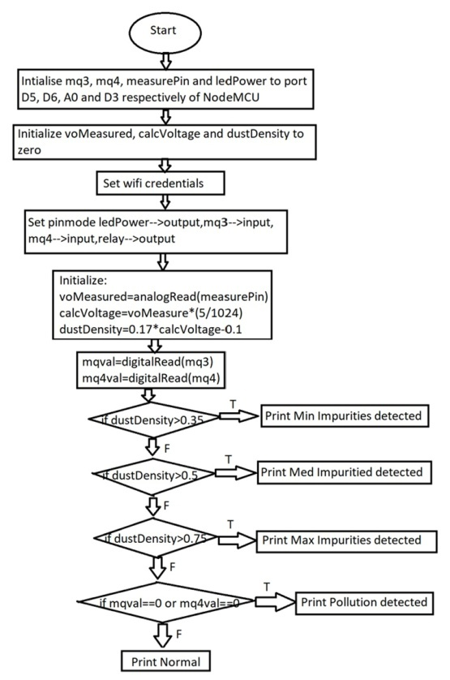

**Fig 9: Flowchart**

* 1. CONCLUSION

A solar based 2-layer air purifier is developed for indoor applications which uses an already proven technic HEPA and activated carbon filter to remove the particulate and gaseous impurities from the atmosphere in a reliable way. The filter has the capability to absorb the particle between PM 2.5 and PM 10 which mainly exist in the atmosphere. The paper provides a strong theoretical understanding towards different types of filters commonly available in the market. The HEPA and activated carbon are trends already existing with the market. However, implementation with solar based solution is a nascent solution in the market which makes the project more unique

ACKNOWLEDGEMENT

This research was partially funded by KSCST under 45th Series of Student Project Programme 2021-22. We thank the entire KSCST team for their constant support throughout the work.

**REFERENCES:**

[1]. Arun Chakravarthy R, Arun M, Bhuvaneswari M (2021), „Waste Management Solution for Smart City using Internet of Things‟ International Journal of Creative Research Thoughts.

[2] Y. Yoda, K. Tamura, S. Adachi, N. Otani, S. F. Nakayama, and M. Shima, “Effects of the use of air purifier on indoor environment and respiratory system among healthy adults,” Int. J. Environ. Res. Public Health, vol. 17, no. 10, 2020.

[3] A. R. K. B and A. Ms, “Self-Sustainable Air Purifier with Air Cooling System,” vol. 7, no. 10, pp. 1–4, 2019.

[4] Design and Fabrication of Solar Powered Air Purifier by Manjeet Kumar1, Satinder Jeet Singh2, Prabhat Kumar Shukla3, Raj Varun Singha4, Volume: 05 Issue: 04 | Apr-2018.

[5] Shengbo Ge, Zhenling Liu, YuzoFuruta, Wanxi Peng, “Characteristics Of activated carbon remove sulphur particles against smog”, Received 16 November 2016; revised 17 December 2016; accepted 18 December 2016.

[6] https://www.health.nsw.gov.au/environment/air/Pages/common-air-pollutants.aspx. [4] Trevor Sparks, George Chase, in Filters and Filtration Handbook (Sixth Edition), 2016.

[7] Cho, Y.K.; Alaskar, S.; Bode, T.A. BIM—Integrated sustainable material and renewable energy simulation. In Construction Research Congress 2010. Innovation for Reshaping Construction Practice; Ruwanpura, J., Mohamed, Y., Lee, S., Eds.; American Society of Civil Engineers: Banff Alberta, AL, Canada, 2010;

[8] Design of an air purifier by David Ardmar, Johan Bodin.

[9] Councils London. The Control of Dust and Emissions from Construction and Demolition— Best Practice Guidance; Councils London: London, UK, 2006.

[10] W.W. Nazaroff, Indoor particle dynamics, Indoor Air 14 (Suppl 7) (2004)175e183.

[11] Delgado, Alexi, and Hugo Flor. "Selection of the best air purifier system to urban houses using AHP." 2017 CHILEAN Conference on Electrical, Electronics Engineering, Information and Communication Technologies (CHILECON). IEEE, 2017.

[12] Singh, Atul P., et al. "Application of Air Purifier Drone to Control Air Pollutants in Domestic and Industrial Areas." 2020 International Conference on Electrical and Electronics Engineering (ICE3). IEEE, 2020.

[13] Bergam, Noah, et al. "Designing and Simulating a Smart Air Purifier to Combat HVAC-induced COVID-19 Transmission." 2020 IEEE MIT Undergraduate Research Technology Conference (URTC). IEEE, 2020.

[14] Marinov, Marin Berov, et al. "Portable air purifier with air quality monitoring sensor." 2019 IEEE XXVIII International Scientific Conference Electronics (ET). IEEE, 2019.

[15] Sharma, Manisha, Ajay Kumar, and Abhishek Bachhar. "I2P air purifier with air quality monitoring device." 2017 2nd International Conference on Communication and Electronics Systems (ICCES). IEEE, 2017.

[16] Wang, Yining, et al. "Design and Research of Intelligent Air Purifier System." 2020 IEEE International Conference on Mechatronics and Automation (ICMA). IEEE, 2020.